Personal Academic Website

Professor Gad Degani

- Home Page

Professor Gad Degani – Aquaculture, Amphibian Biology and Molecular Ecology
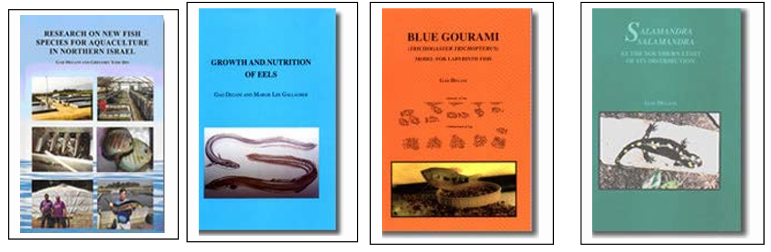
Short introduction
Professor Gad Degani is a senior researcher specializing in aquatic biology, amphibian ecology, and aquaculture physiology. His research integrates ecology, molecular biology, endocrinology, and environmental science to understand the biology and conservation of aquatic organisms.
His work focuses particularly on:
• Amphibian ecology and conservation in the Middle East
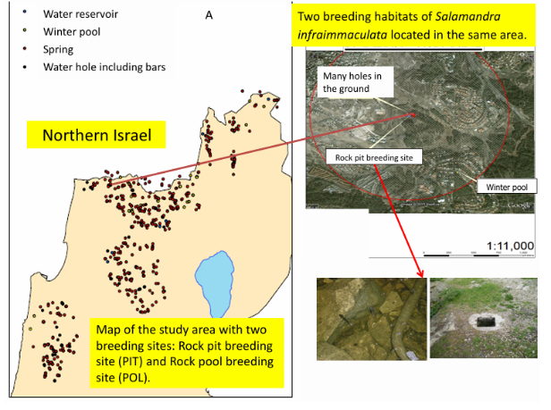
• Reproductive biology of fish and amphibians
• Aquaculture systems and fish physiology
• Molecular mechanisms of sex determination in fish
• Environmental adaptation of aquatic organisms
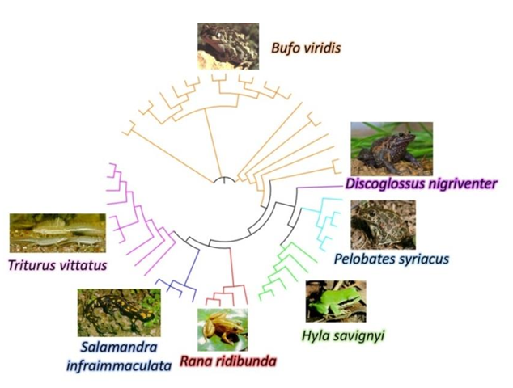

Professor Degani has published numerous scientific papers and books and has contributed to the development of applied biological research in northern Israel.

2. About Professor Gad Degani
Position
Emeritus Professor of Biology
Affiliation
MIGAL – Galilee Research Institute
Faculty of Science, Tel-Hai University, Kiryat Shmona, Israel
Fields of Expertise
Aquaculture Biology
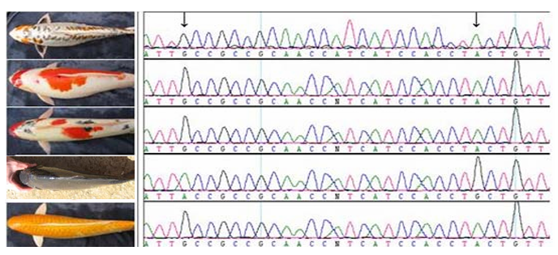
Amphibian Ecology
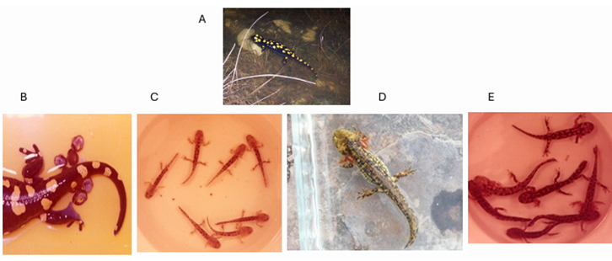
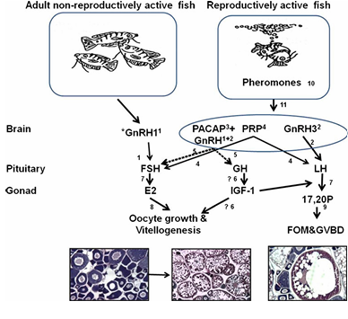Fish Reproductive Physiology
Molecular Sex Determination in Fish
Environmental Adaptation of Aquatic Species
Conservation Biology
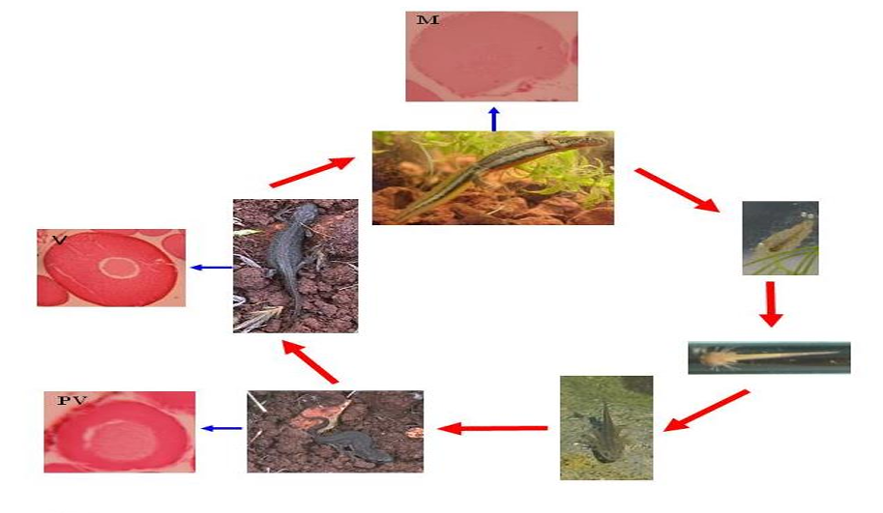
Academic Interests
Professor Degani’s research integrates field ecology, molecular biology, and aquaculture science to understand how aquatic organisms reproduce, grow, and adapt to environmental conditions.

3. Research Areas

Amphibian Ecology and Conservation

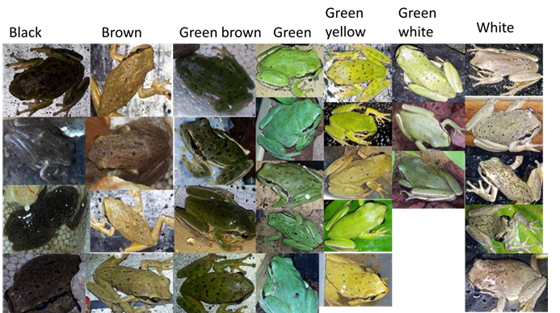
Research on amphibians in Mediterranean and desert environments, including:
Salamandra infraimmaculata
Ommatotriton vittatus
Bufotes viridis
Pelophylax bedriagae
Studies include:
• Life cycle and reproduction
• Habitat ecology
• Distribution patterns in Israel
• Environmental constraints on populations

Fish Reproductive Physiology
Research on hormonal regulation of reproduction in fish species such as:
Trichogaster trichopterus (Blue Gourami)
Russian sturgeon (Acipenser gueldenstaedtii)
Focus areas:
• Brain-pituitary-gonad axis
• Hormonal regulation of spermatogenesis
• Environmental control of reproduction
• Behavioral and endocrine interactions

Molecular Sex Determination
Development of molecular markers for early sex identification in aquaculture species, especially sturgeon.
Research includes:
• Genetic markers for sex determination
• Molecular diagnostics in aquaculture
• Application in caviar production systems

Aquaculture and Fish Farming Systems
Development of efficient aquaculture systems including:
• Sturgeon farming for caviar production
• Closed water aquaculture systems
• Coral aquaculture technologies

4. Current Research Projects

Molecular Sex Identification in Russian Sturgeon
Development of molecular markers for early identification of male and female juveniles.

Epitranscriptomic Regulation (m6A) in Fish and Amphibians
Investigation of RNA methylation patterns in brain and gonadal tissues.

Ecology of Salamandra infraimmaculata in Northern Israel
Study of habitat constraints, larval development, and seasonal dispersal patterns.

Coral Aquaculture Production Systems
Development of closed-water systems for coral propagation.

5. Selected Publications
Degani, G. (2024)
Biological Adaptations of Anuran Species across Diverse Habitats, Spanning Mediterranean to Desert Climates. Scientific Research Publishing.
Degani, G., & Levanon, D. (2025)
Development of an Applied Academic Research Institute in a Peripheral Region.
Degani, G. et al.
Multiple studies on amphibian ecology and fish reproductive physiology published in international journals.

6. Books
Biological Adaptations of Anuran Species across Diverse Habitats
Scientific Research Publishing, 2024
This book describes ecological adaptations of amphibians across environmental gradients ranging from Mediterranean ecosystems to desert climates.

7. Field Research Sites
Major research areas include:
Hula Valley
Upper Galilee
Golan Heights
Mount Hermon region
Key study sites include:
Zavitan Stream
Dan Stream
Sasa breeding pools
Seasonal Mediterranean ponds

8. Laboratory Research
Laboratory work includes:
Molecular genetics
RNA analysis
Gene expression studies
Hormone analysis
Technologies used:
PCR
RNA sequencing
Molecular markers
Endocrine assays

9. Collaborations
Professor Degani collaborates with researchers in:
Israel
Europe
United States
Fields include:
Aquaculture science
Evolutionary biology
Environmental ecology
Molecular biology

10. Contact
Professor Gad Degani
MIGAL – Galilee Research Institute
Tel-Hai Academic College
Upper Galilee, Israel
Email
gad@migal.org.il
gdgd1943@gmail.com

11. Download Section
Visitors can download:
Scientific publications
Research reports
Scientific figures and models
Datasets related to amphibian and fish research

12. Gallery
Images and scientific illustrations of:
Amphibian life cycles
Fish reproductive systems
Field research sites
Experimental systems

13. News and Updates
Recent publications
New research projects
Conference presentations
Field research updates

Suggested Website Title
Professor Gad Degani – Aquatic Biology, Amphibian Ecology and Aquaculture Research

1️⃣

